IT LAB WEEK 1 :

QUESTION 1) :

1. <html>
2. <head>
3. <script src="https://ajax.googleapis.com/ajax/libs/jquery/3.5.1/jquery.min.js"></script>
4. <script script type="text/javascript">
5. $(document).ready(function () {
6. $("button").click(function(){
7. $("div").animate({left:'250px'})
8. });
9. $(".ro").css("background-color", "blue");
10. $(".re").css("background-color", "cyan");
11. });
12. </script>
13. </head>
14. <body>
15. <div style="position: relative;">
16. <table id="t1" width="400px" height="200px">
17. <tr class="ro">
18. <th>SNo.</th>
19. <th>Name</th>
20. <th>Age</th>
21. </tr>
22. <tr class="re">
23. <td>1</td>
24. <td>raj</td>
25. <td>10</td>
26. </tr>
27. <tr class="ro">
28. <td>2</td>
29. <td>vardhan</td>
30. <td>19</td>
31. </tr>
32. <tr class="re">
33. <td>3</td>
34. <td>reddy</td>
35. <td>25</td>
36. </tr>
37. </table>
38. <br><br>
39. <img id="i1" src="smiley_img1.jfif">
40. </div>
41. <br><br>
42. <button id="bt">Click the button to move table and image</button>
43. </body>
44. </html>

IMAGES (screen shots of 1st question) :

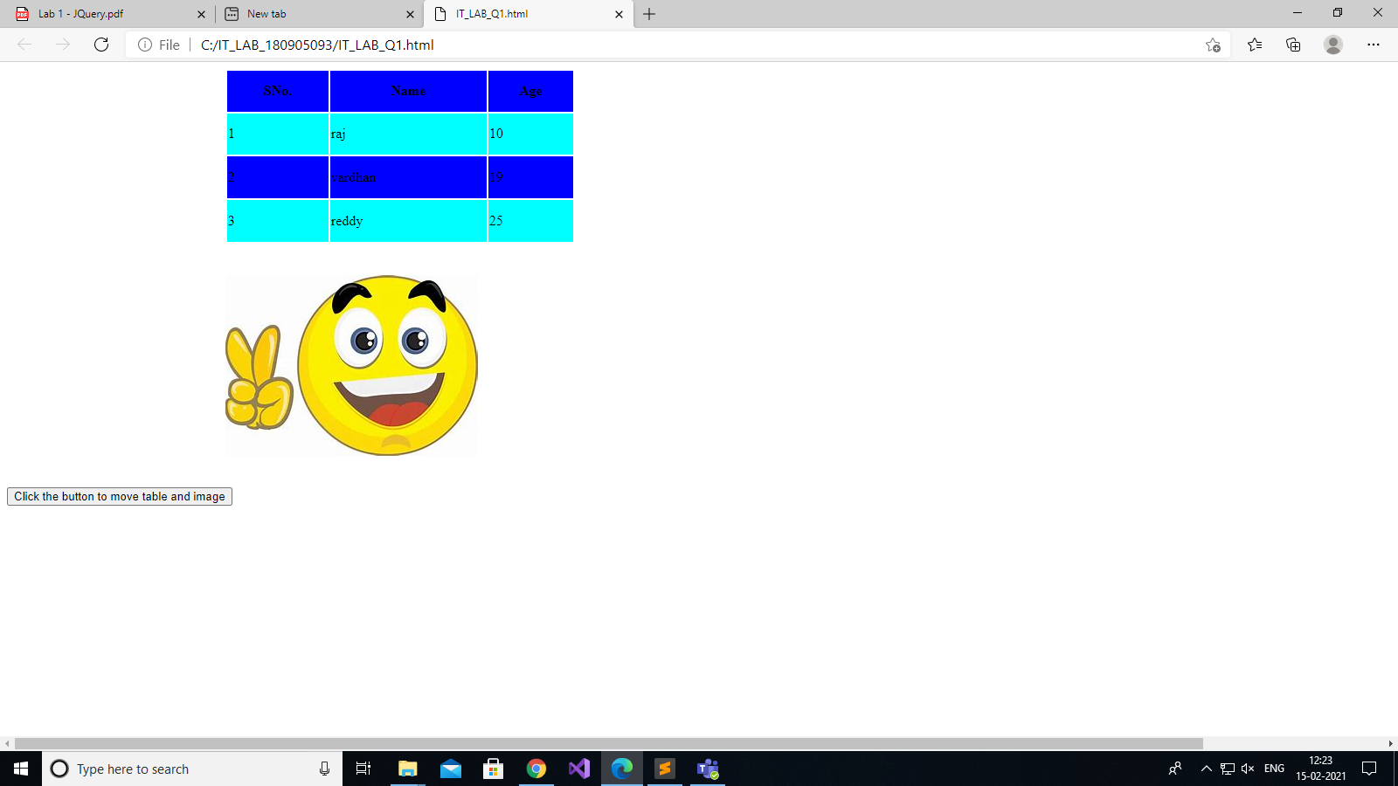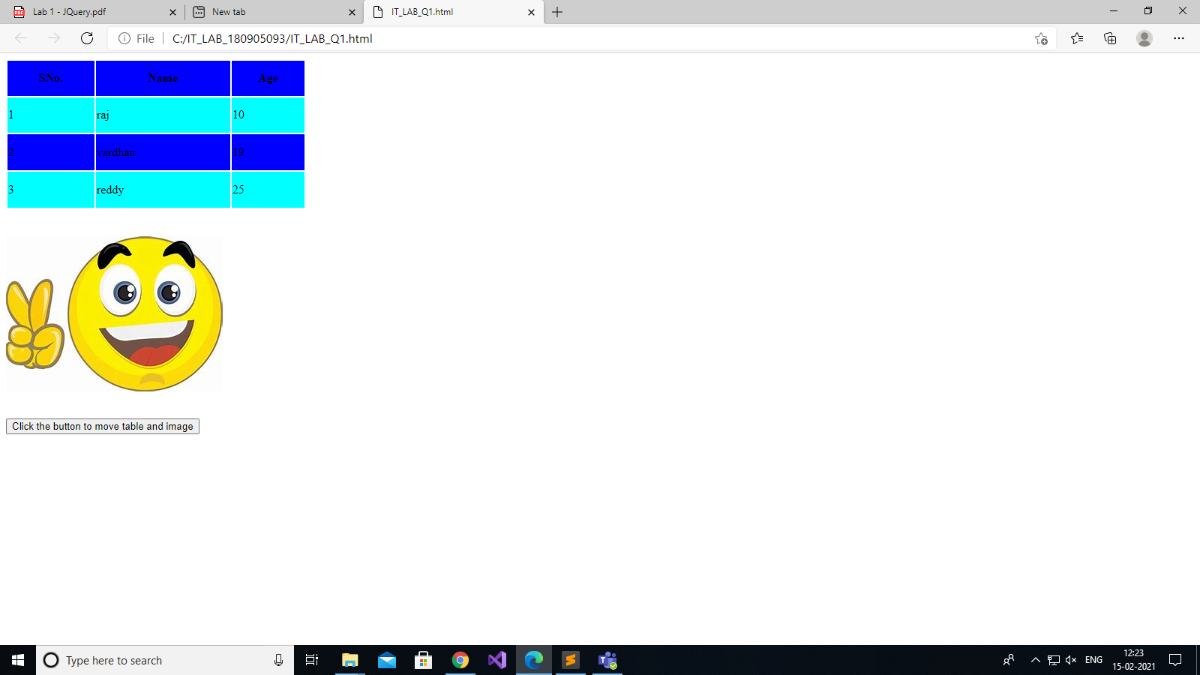

QUESTION 2 :

<html>

<head>

<title>

CALCULATOR for Arithmetic Operations

</title>

<script src="https://ajax.googleapis.com/ajax/libs/jquery/3.4.0/jquery.min.js"></script>

<script>

//cdn//

$(document).ready(function(){

$("#btnAdd").on('click',function(){

Add();

});

$("#btnSubstract").on('click',function(){

Substract();

})

$("#btnMultiply").on('click',function(){

Multiply();

})

$("#btnDivide").on('click',function(){

Divide();

})

});

function Add(){

var no1=parseInt($("#txtNo1").val());

var no2=parseInt($("#txtNo2").val());

var result =no1+no2;

alert("The result is "+result);

}

function Substract(){

var no1=parseInt($("#txtNo1").val());

var no2=parseInt($("#txtNo2").val());

var result =no1-no2;

alert("The result is "+result);

}

function Multiply(){

var no1=parseInt($("#txtNo1").val());

var no2=parseInt($("#txtNo2").val());

var result =no1*no2;

alert("The result is "+result);

}

function Divide(){

var no1=parseInt($("#txtNo1").val());

var no2=parseInt($("#txtNo2").val());

var result =no1/no2;

alert("The result is "+result);

}

</script>

</head>

<body>

Please Enter First Number <input type="text" id="txtNo1" placeholder="Enter first number"><br>

Please Enter Second Number<input type="text" id="txtNo2" placeholder="Enter second number"><br>

<input type="button" id="btnAdd" value="Addition">

<input type="button" id="btnSubstract" value="Subtraction">

<input type="button" id="btnMultiply" value="Multiplication">

<input type="button" id="btnDivide" value="Division">

</body>

</html>

IMAGES (screen shots of 2nd question) :

For Addition :

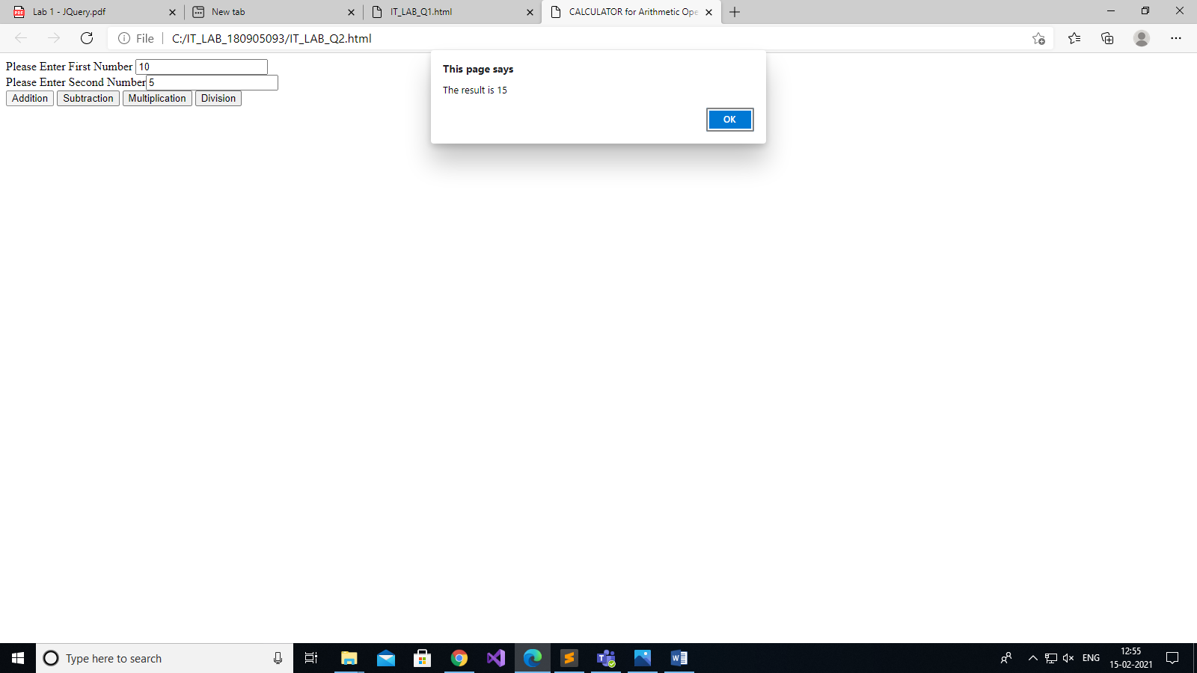

For Subtraction :

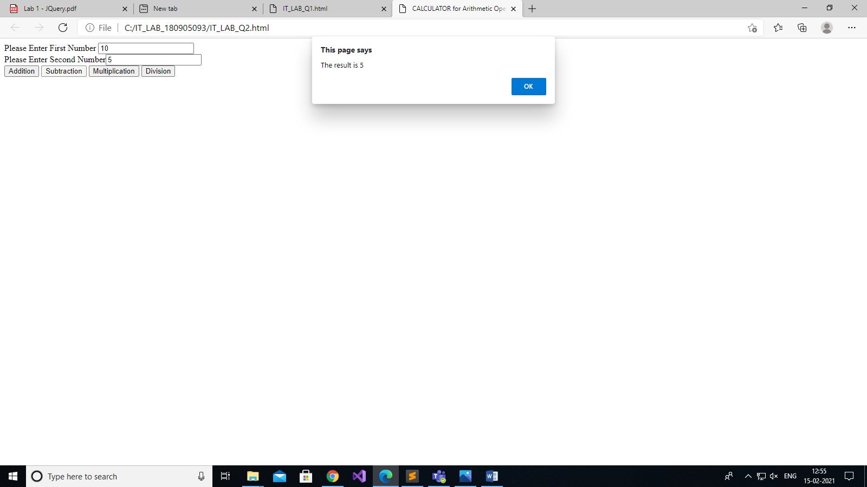

For Multiplication :

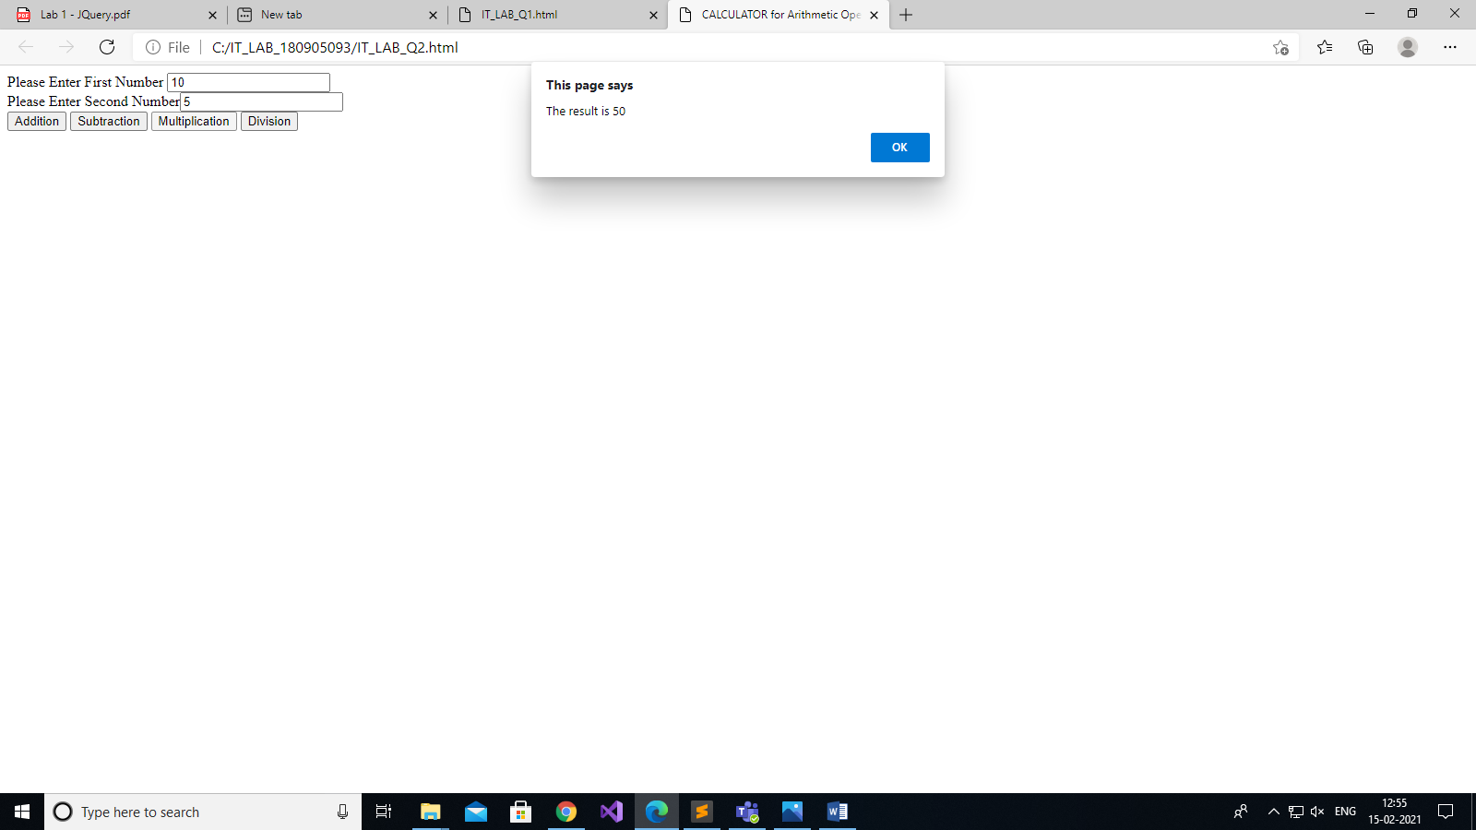

For Division :

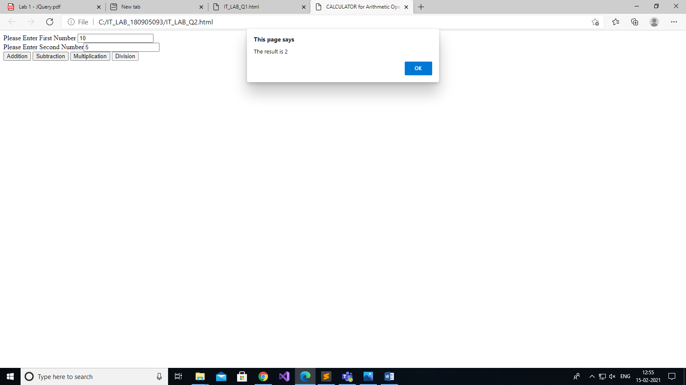

QUESTION 3 :

<!DOCTYPE html>

<html>

<head>

<title>q3</title>

<script src="https://ajax.googleapis.com/ajax/libs/jquery/3.5.1/jquery.min.js"></script>

<script type="text/javascript">

$(document).ready(function() {

$("#update").click(function(){

var style = $('input[type="radio"]:checked').val();

var color = $('#colors').val();

var font = $('#font').val();

var fontsize = $("#size").val();

var checkbox = $('input[type="checkbox"]:checked').val();

var text = $("#textbox").val();

$("#card").css("background-color",color);

$("#card").css("border-style",style);

$("#card").css("font-size",fontsize);

$("#card").css("font",font);

$("#card").html(text);

if(checkbox){

// $('#card').css({"background-image", url("img1.png")});

var imageUrl = "img1.png";

$("#card").css("background-image", "url(" + imageUrl + ")");

$("#card").css("background-size","75% 50%" );

$("#card").css("background-repeat","no-repeat" );

$("#card").css("background-position","center" );

}

else{

$("#card").css("background-image", "none");

}

});

});

</script>

</head>

<body>

<table style="width:100%">

<td>

Choose a background color: <br><select name="colors" id="colors">

<option value="yellow">Yellow</option>

<option value="orange">Orange</option>

</select>

<br>

<br>

Choose a font: <br><select name="font" id="font">

<option value="verdana">Verdana</option>

<option value="'Courier New'">Courier New</option>

</select>

<br>

<br>

Enter font size: <br> <input type="size" id="size"></input>

<br>

Choose a border style:<br> <input type="radio" id="None" name="border-style" value="None">

<label for="None">None</label><br>

<input type="radio" id="Double" name="border-style" value="Double">

<label for="Double">Double</label><br>

<input type="radio" id="Solid" name="border-style" value="Solid">

<label for="Solid">Solid</label>

<br>

<br>

<input type="checkbox" id="picture" name="picture" value="pic">

<label for="picture"> Add default picture</label>

<br>

<br>

Enter greeting text below: <br> <input type="text" id="textbox"></input>

<br>

<button id="update">Update</button>

<br>

<br>

</td>

<td>

<div id ="card" style="height: 400px; width: 300px;background: yellow" ></div>

</td>

</table>

</body>

</html>

IMAGES (screen shots of 3rd question) :

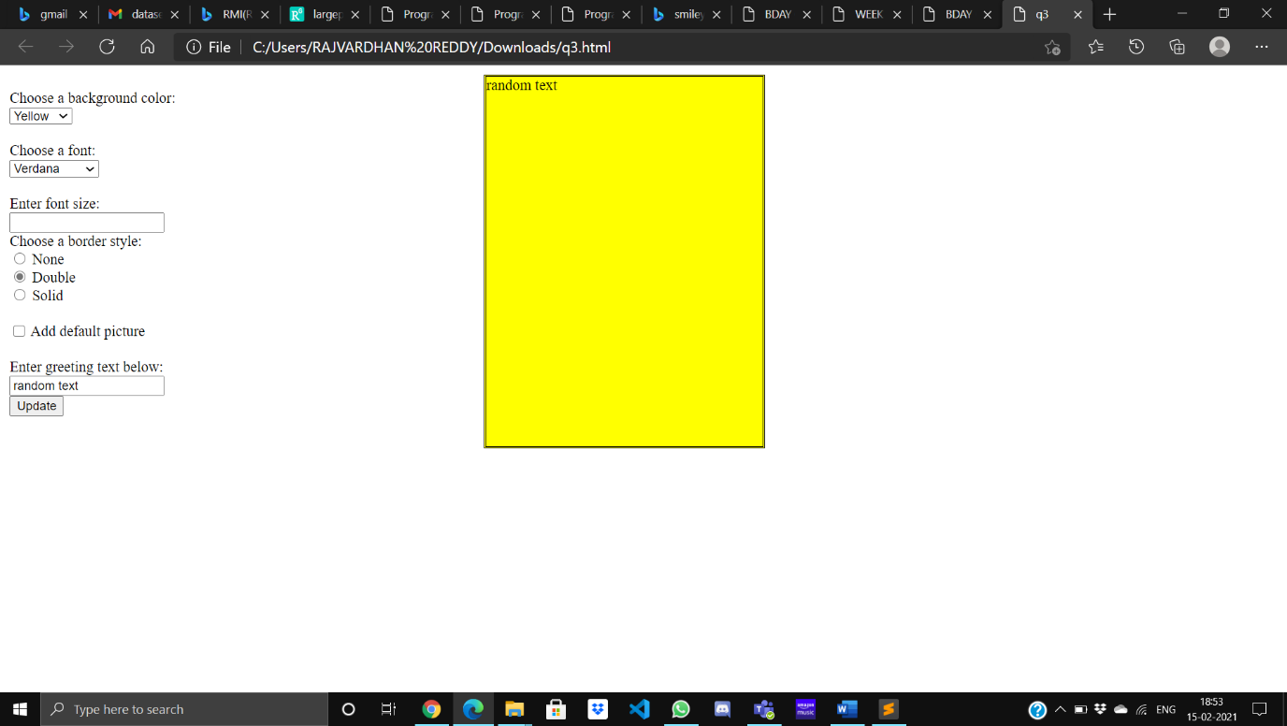

Question 4 :

<!DOCTYPE html>

<html lang="en">

<head>

<meta charset="UTF-8">

<meta http-equiv="X-UA-Compatible" content="IE=edge">

<meta name="viewport" content="width=device-width, initial-scale=1.0">

<title>WEEK 1 Q4</title>

<script src="https://ajax.googleapis.com/ajax/libs/jquery/3.5.1/jquery.min.js"></script>

<script type = "text/javascript" language = "javascript">

$(document).ready(function(){

$('#bill').click(function(){

let brand_name = $('#brand-choice').val();

let quan = $('#quantity').val();

console.log({quan});

let amt = 0;

let price = 0;

if(brand_name == 'HP'){

if($('#laptop').prop("checked") == true){

price = 10000;

}

else{

price = 5000;

}

}

else if(brand_name == 'Nokia'){

if($('#laptop').prop("checked") == true){

price = 11000;

}

else{

price = 6000;

}

}

else if(brand_name == 'Samsung'){

if($('#laptop').prop("checked") == true){

price = 12000;

}

else{

price = 7000;

}

}

else if(brand_name == 'Motorola'){

if($('#laptop').prop("checked") == true){

price = 13000;

}

else{

price = 8000;

}

}

else{

if($('#laptop').prop("checked") == true){

price = 14000;

}

else{

price = 9000;

}

}

let n = parseInt(quan);

amt = n*price;

alert(amt);

});

});

</script>

</head>

<body>

<p>

<table>

<tr>

<td>Brand</td>

<td>Laptop</td>

<td>Mobile</td>

</tr>

<tr>

<td>HP</td>

<td>10000</td>

<td>5000</td>

</tr>

<tr>

<td>Nokia</td>

<td>11000</td>

<td>6000</td>

</tr>

<tr>

<td>Samsung</td>

<td>12000</td>

<td>7000</td>

</tr>

<tr>

<td>Motorola</td>

<td>13000</td>

<td>8000</td>

</tr>

<tr>

<td>Apple</td>

<td>14000</td>

<td>9000</td>

</tr>

</table>

</p>

<label for="brand-choice">Choose a Brand:</label>

<input list="brands" id="brand-choice" name="brand-choice" />

<datalist id="brands">

<option value="HP"></option>

<option value="Nokia"></option>

<option value="Samsung"></option>

<option value="Motorola"></option>

<option value="Apple"></option>

</datalist>

<p>Choose:</p>

<div>

<input type="checkbox" id="laptop" name="laptop" checked>

<label for="laptop">Laptop</label>

</div>

<div>

<input type="checkbox" id="mobile" name="mobile">

<label for="mobile">Mobile</label>

</div>

<div>

<label for="quantity">Quantity</label>

<input type="text" id="quantity" name="quantity" required>

</div>

<button id="bill">Bill Amount</button>

<p id="write-bill"></p>

</body>

</html>

IMAGES (screen shots of 4th question) :

